Vocabulary Definitions

Student Name
Institution
Course Name
Instructor Name
Date

Antibiotic
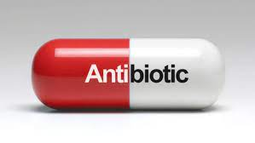
An antibiotic is a type of medicine used to stop or treat infections caused by bacteria in humans, plants, or animals. The medicine involves a natural or synthetic substance that either destroys the microorganisms or inhibits their multiplication.

Cell
A cell is the basic structural unit of living things. Trillions of cells from the body of a living thing contain the genetic material necessary to form the structure for the body. Each cell has a fluid containing water and chemicals in a wrapped membrane. The cells help taking nutrients from food, converting the nutrients into energy and other specialized functions.
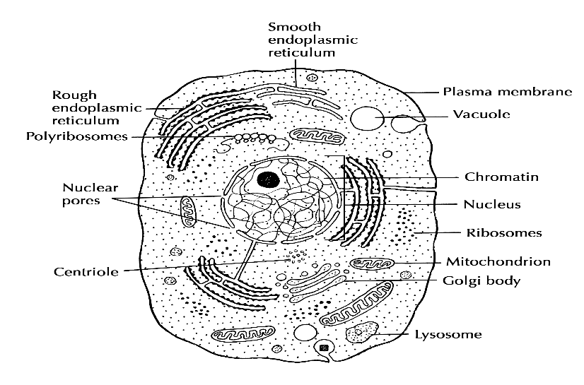

Host
A host is a living organism on or from which a parasite lives or a cell structure upon which a virus can replicate itself. Hosting can involve a larger animal that accommodates another, whether parasitic, mutualistic, or symbiotic, for shelter or nourishment. A host can also be the recipient of tissue or organ graft.

Virus
A virus is a microorganism that invades living cells and uses their chemical compositions to keep itself alive or replicated. It can reproduce in the same form but can also reproduce with mutations, making their treatment difficult. Viruses may contain either DNA (Deoxyribonucleic acid) or RNA (Ribonucleic acid) in their genetic compositions.
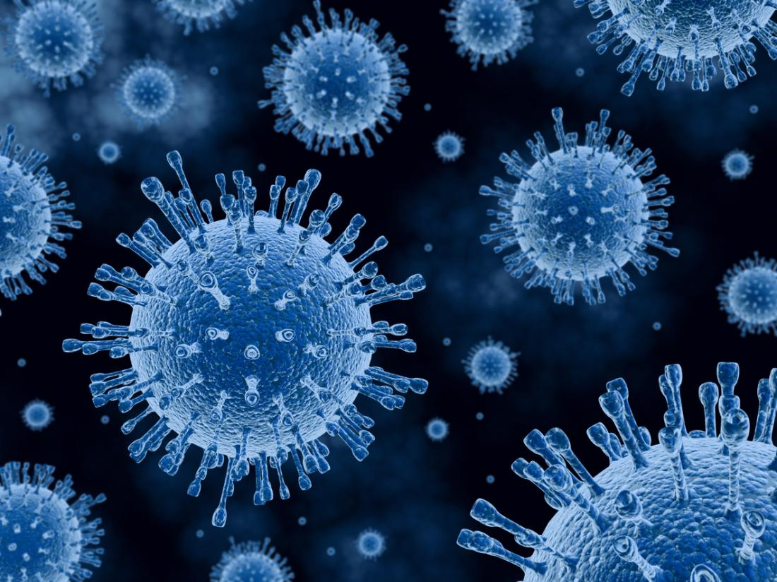
Superinfection
A superinfection is an infection that reoccurs following a previous infection, especially caused by resistant microorganisms or microorganisms resistant to antibiotics previously used.
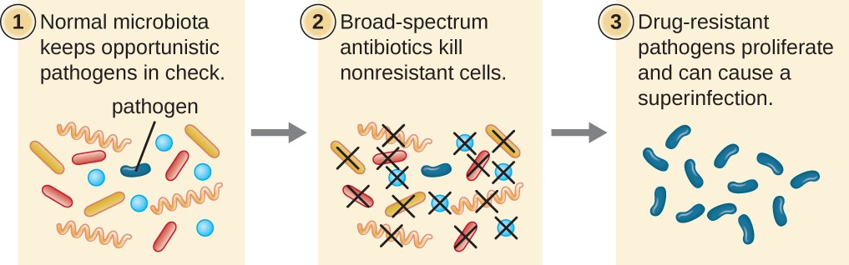
MRSA (Methicillin-resistant Staphylococcus aureus)
MRSA is a bacterium that is resistant to most of the common antibiotics. It causes infections in different parts of the body that are difficult to treat. MRSA symptoms depend on the area of the body that is affected, but the most common forms of infection are sores, boils, or abscesses. MRSA could also cause serious infections such as the skin, surgical wounds, the bloodstream, lungs, or the urinary tract.
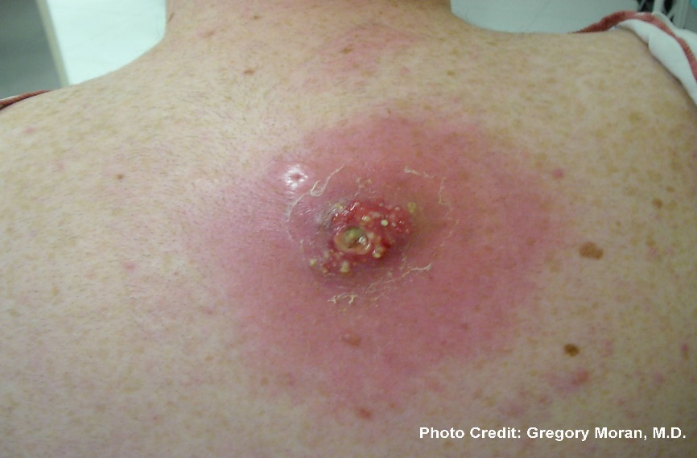
Acquired resistance
Acquired resistance occurs when a particular microorganism gains the ability to resist a particular antimicrobial agent's effect, to which they were previously susceptible. Acquired resistance can be caused either by gene mutation or from foreign resistant genes or can be both.
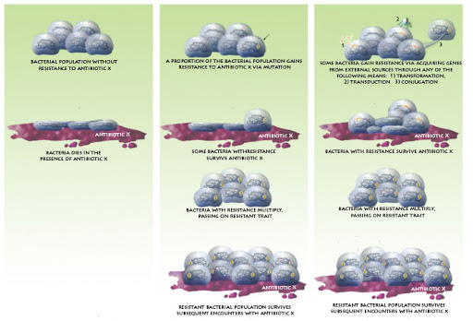
Bactericidal vs. bacteriostatic
Bactericidal refers to the agents that kill bacteria. In contrast, bacteriostatic refers to the drugs that slow down or pauses bacteria's growth, giving the body a chance to kill them.
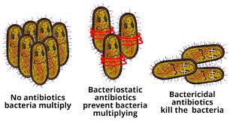
Antivirals
An antiviral is an agent used to kill a virus or halts its ability to replicate, thereby inhibiting its reproduction or multiplication. Antivirals help reduce the severity of disease since the virus multiplies rapidly, making it difficult to kill them.
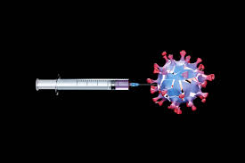
Retroviral
Retroviral infections are types of infections where a virus uses special enzymes to insert a copy of its RNA into the hosts' DNA, thereby changing its cells' genotype. With the virus accessing the hosts' DNA, it can reproduce additional viral components.
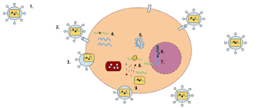
HIV (human immunodeficiency virus)
HIV is a type of virus that affects the body's immune system, which leads to AIDS (Acquired immunodeficiency syndrome). There exist no cure for HIV, but patients rely on medication to control its effects on the body.
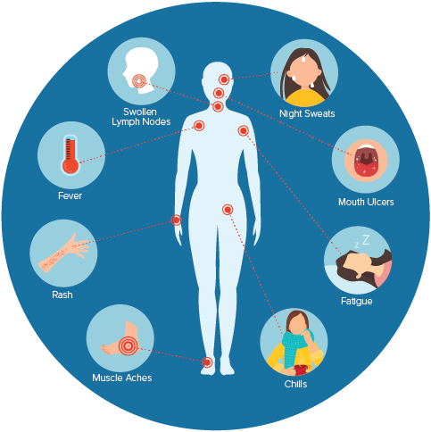
HAART (Highly active antiretroviral therapy)
HAART is a type of medication used to manage and treat human immunodeficiency virus type 1. It helps stop the virus from making copies of itself in the hosts' bodies.

HPV (Human papillomavirus)
HPV is a group of viruses that can cause warts in different parts of the body. The viruses can be spread through skin-to-skin contact, sexual intercourse, or other sexual contacts.
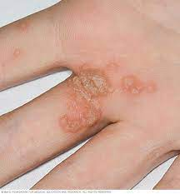
HERPES
Herpes is a sexually transmitted infection caused by the herpes simplex virus. It can be oral, which causes sores around the mouth or on the face, or genital, which affects the genital area, anal area, and buttocks.
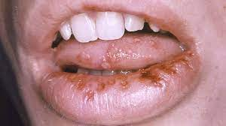
INFLUENZA
Influenza is a contagious viral infection that affects the upper and lower respiratory tract, with symptoms of fever, chills, and general body weakness, among others.
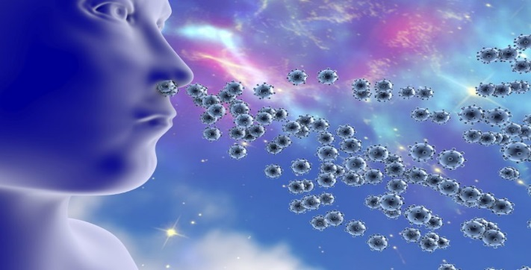
COVID
The COVID-19 (Corona Virus Disease) is a contagious respiratory illness caused by a new coronavirus strain. Commons symptoms are cough, fever, tiredness, and shortness of breath.
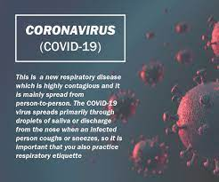
HEPATITIS
Hepatitis is an inflammatory liver condition caused by, among other causes, a viral infection. Hepatitis could occur because of a secondary reaction to a medication, drugs, toxins, or alcohol.
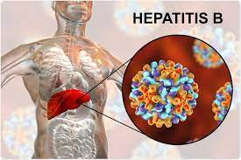
References
Clancy, C. J., & Nguyen, M. H. (2020). Coronavirus disease 2019, superinfections, and antimicrobial development: What can we expect? Clinical Infectious Diseases, 71(10), 2736-2743. https://doi.org/10.1093/cid/ciaa524
Liaw, Y., Chen, Y., Sheen, I., Chien, R., Yeh, C., & Chu, C. (2004). undefined. Gastroenterology, 126(4), 1024-1029. https://doi.org/10.1053/j.gastro.2004.01.011
Rossi, G. A., Fanous, H., & Colin, A. A. (2020). undefined. Pediatric Pulmonology, 55(4), 1061-1073. https://doi.org/10.1002/ppul.24699
Smith, D., Richman, D., & Little, S. (2005). HIV superinfection. The Journal of Infectious Diseases, 192(3), 438-444. https://doi.org/10.1086/431682

